Simultaneous Movements

1. XZ plane

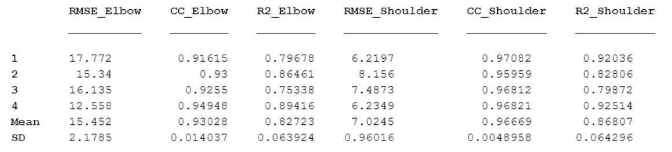

1. XY plane

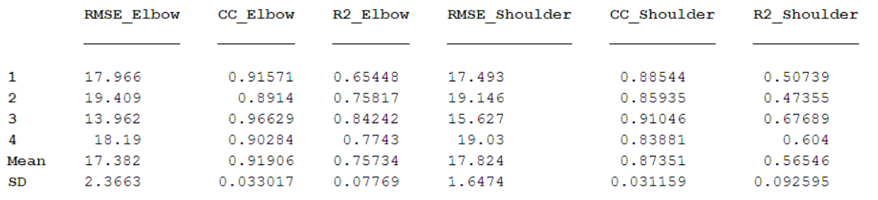

1. YZ plane

